Chair’s Report

Hollowell and Teeton Village Hall (2021/22)

The Committee considers that their prime function is to improve and maintain the fabric of the Village Hall as funds allow, to organise fundraising and non-fundraising social events for the village that create a sense of a community and to maintain a safe environment. This report details activity during the financial year 2021/22.

Health and Safety

During this year the village hall has remained, in part, closed due to Covid and restrictions imposed nationally, legally and locally. The committee have continued to meet to discuss closures, restrictions and re-opening. Maintenance visits have continued weekly despite closure. There have been no notifiable health and safety events within the last year.

Refurbishment of the Hall

The second phase of the roof works has been completed, focus being on clearing moss from the kitchen roof, the bar/toilet/foyer extension roofs, and the table store roof. Also undertaken were leak rectification and prevention works on the table store roof which involved repointing, re-seating and partial re-flashing of the valleys, and some cement fillet renewal to the parapets; additional re-bedding and re-pointing of the apex tiles was also included.

Social Activity

National and local guidance around closure have continued to impact our events calendar significantly, but we were really pleased to host a village families and children’s Halloween party in October, welcome back We Are Hopewell for their coffee mornings and host our own Big Breakfast in March. Planned future events include a Steam and Whistle pub and quiz night in April, a BBQ in June, Big Breakfast in September, Harvest Supper and Halloween party (as separate events) in October and a Café Christmas to end the year. We have also been able to rent the space for birthdays, christenings, the Hollowell Hens and a wedding! It has been fantastic to see the hall open for business and back to being a hub for the community.

Finance

Please see the Treasurer's report for more detailed Village Hall accounts.

Highlights to include are listed below.

Incoming:

£2476.85 donated by Hollowell Fete and Flower Festival
£2667 Covid Grant awarded by West Northants Council

Outgoing:

26th July Cleaner appointed £12phr 3 hrs every 2 weeks

Community

The Village Hall remains an emergency centre, meaning residents of Hollowell who find themselves in need of warmth and shelter due to unprecedented and urgent circumstances can access the hall. There they will find a Covid emergency first aid box and emergency box, which includes money for the heaters and access to warm blankets as well as other necessary items. The cost of this has been fully supported by the We Are Hopewell team who, together with the Parish Council, organised and financed the boxes and equipment, now situated under the bar in the foyer should the need ever arise. We Are Hopewell have rebooked their coffee mornings in at the hall to support people who may feel isolated or just in need of a coffee and a chat. Emily Curtis is also working on a co-ordinated village response to the Ukrainian crisis, and the hall may be able to provide practical space depending on the impact to the village and its residents. We also look forward to our role in the upcoming Queens jubilee in June, details yet to be confirmed.

I would like to take this opportunity to thank the wider committee for their continued contributions and support over the past year and my time as Chair. I will be stepping down at our AGM and wish the next Chair luck for everything yet to come.

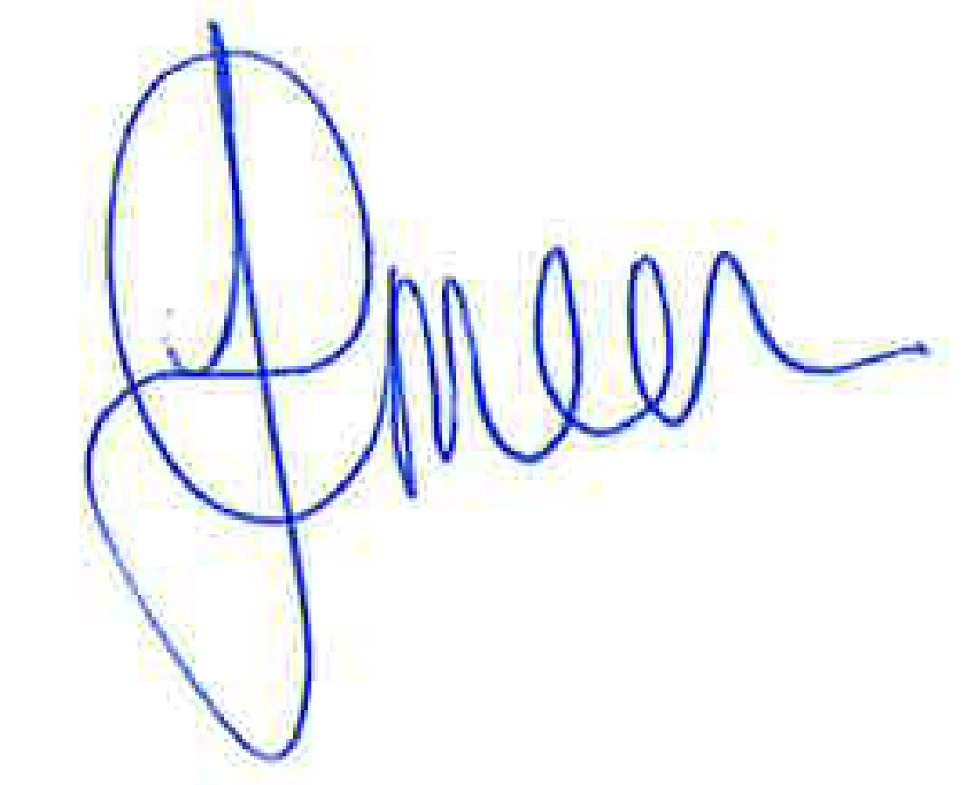
Julia Green
Chair

