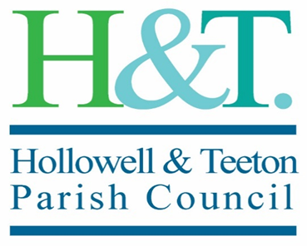
Vacancy on the Parish Council – Teeton Ward

Hollowell & Teeton Parish Council has a vacancy for a parish councillor for Teeton Ward.

Expressions of interest are welcomed from anyone from Teeton who is over 18 years old and has an interest in the community.

As a councillor representing your community you will help keep it a great place to live and work. You will be supported in your role and will be expected to undertake training. You should be comfortable working electronically. You should have a positive outlook and a can-do attitude and be willing to work as part of a team.

If you are interested in joining the council, please contact the Clerk, Gillian Greaves, for more information on 07771980598 or by e-mail at pc-clerk@hollowellandteeton.org.uk

The Parish Council ordinarily meets bi-monthly in the evening on a
Wednesday. If you care about your community and would like to help to make a real difference, then why not…

Become a Parish Councillor!

The council is holding a meeting on [Wed 19 May 2021].
You will be invited to come along and say briefly why you wish to join the council. There will then be a vote of the existing councillors.

