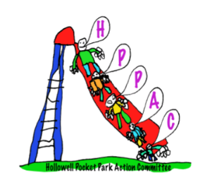

**HPPAC Chair Report**

**2020/21**

2020 saw the installation of 2 new picnic tables sited in and around the existing play equipment. Later inspection and reports of the seats ‘bowing’ confirmed the provider had delivered the incorrect product and they have since delivered 2 further tables, at no additional cost. We understand that the Parish Council will install the tables as soon as the weather allows. This will provide additional seating for visitors to the park; the picnic tables already installed in proving incredibly popular over the last few weeks and months. In fact, the park has been very heavily frequented during the last 2 lockdowns and as a committee, we acknowledge and consider the inevitable wear and tear of the equipment and potential impact on Hollowell residents regarding (additional) car parking near the pocket park, which we continue to monitor.

2021 (July) sees the return of the Hollowell FAFF. The Pocket Park team remain heavily involved with supporting in the organisation of and build up to the event and practically over the course of the 2 days and will be in receipt of the divided profits, along with the Church and Village Hall.

We continue as a committee of 4, myself as Chair, Emily Curtis (Treasurer), Hannah Oswin (Secretary) and our committee member Dawn Fountain.

Our thanks, as always to the residents of Hollowell and the Parish Council for their continued support.

It was particularly lovely to receive this recent feedback from a Hollowell resident…

**The Pocket Park**

As a fairly new grandmother of a toddler I have come to fear the question ‘Would you like to take her to the park?’ The answer is usually a resounding no! Why would I want to spend an hour in the company of hordes of children and weary parents?

There’s one exception however. Our Pocket Park is beautiful. It’s well planned, safe and interesting and such an amazing setting. It buys me an hour of smiles and co-operation.

Thank you to the untiring committee who have gifted their time to give our village such a wonderful resource. As my visiting American co-grandmother said, ‘You are so lucky to have this lovely place in your village.’



**Julia Green**

**HPPAC Chair**